"Netflix Shows Dataset Analysis: Uncovering Insights and Trends"

Slide 1: Title Slide
- Title: Netflix Shows Dataset Analysis
- Subtitle: Uncovering Insights from Netflix's Content Catalog
- Presenter Name: [Mary Kwamboka]
- Date: [13-june-2024]

Slide 2: Introduction

Title: Introduction
Content:
- Dataset Overview: The dataset used for this analysis is the Netflix Shows dataset. It includes various attributes such as genre, title, type, director, cast, country, release year, rating, duration, listed genres, and description.
- Origin: The data is sourced from Netflix's extensive content catalog, which provides a diverse collection of TV shows and movies available on the platform.
- Main Goal: The primary goal of this analysis is to explore and uncover interesting patterns and insights within the Netflix Shows dataset. By examining different aspects of the data, we aim to understand trends in content production, popular genres, average show durations, and more.
Slide Design
Dataset Overview:
- Dataset: Netflix Shows
- Attributes: Genre, title, type, director, cast, country, release year, rating, duration, listed genres, description.
Origin:
- Data sourced from Netflix's extensive content catalog.
Main Goal:
- To analyze the dataset and uncover interesting patterns and insights.
- Understand trends in content production, popular genres, and average show durations.

Slide 3: Dataset Overview
Title: Dataset Overview
Content:
- Key Attributes:
  - Genre: The category or genre of the show.
  - Title: The name of the show or movie.
  - Type: Indicates whether the content is a movie or a TV show.
  - Director: The director of the show or movie.
  - Cast: Main cast members of the show or movie.
  - Country: Country of origin or production.
  - Release Year: The year the show or movie was released.
  - Rating: Content rating (e.g., PG, R).
  - Duration: Length of the show or movie (in minutes or number of seasons/episodes).
  - Listed Genres: Genres under which the show or movie is listed.
  - Description: A brief description of the show or movie.
- Number of Records: [Total records in the dataset]
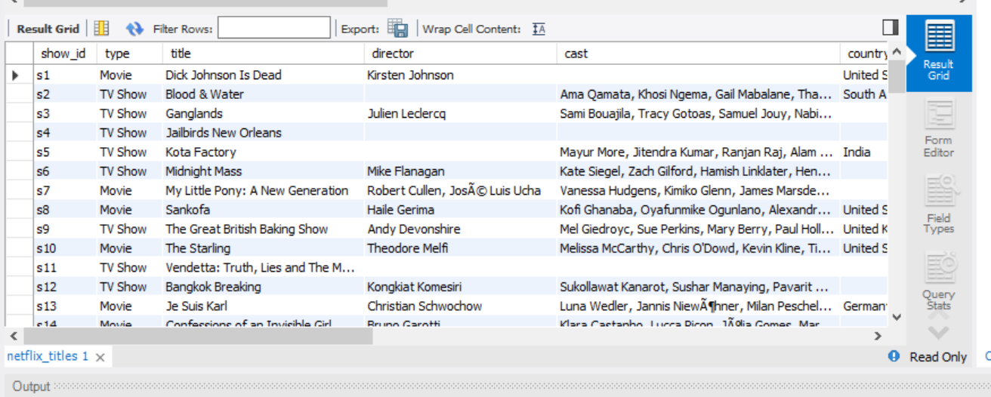

Slide 4: Import Process
Content:
Description of the Importing Process

- Step 1: Downloaded the Netflix Shows dataset in CSV format.
- Step 2: Opened MySQL Workbench and connected to the database.
- Step 3: Used the "Table Data Import Wizard" to import the CSV file.
- Step 4: Mapped the CSV columns to the database table columns.
- Step 5: Verified the imported data by running a simple SELECT query.
Challenges Faced:
- Handling inconsistent data formats, such as mixed duration units.
- Managing missing values in certain columns.
- Ensuring correct data type mapping to avoid import errors.

Slide 5: Interesting Observation
Title: Interesting Observation
Content:
- Genre Diversity:
  - The dataset includes a wide range of genres such as Drama, Comedy, Documentary, Horror, and more.
  - Reflects Netflix's diverse content offerings aimed at different audience preferences.
- Global Representation:
  - The dataset features shows from numerous countries, showcasing Netflix's global reach.
  - Highlights Netflix's strategy to cater to international markets with localized content.
- Initial Interesting Findings:
  - Significant number of entries from the USA, India, and the UK.
  - Notable representation from non-English speaking countries, indicating a strong push for international content.
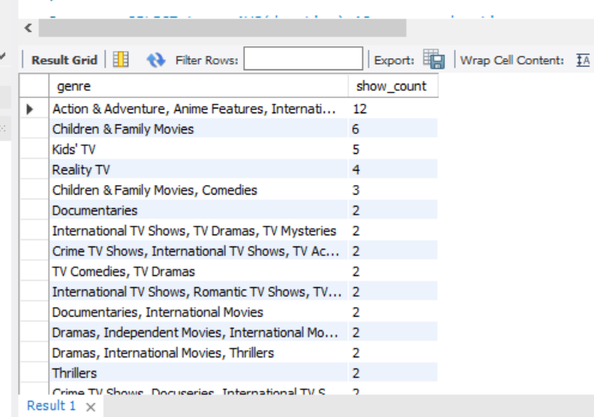

Slide 6: Cool Fact 1 - Genre Count
Title: Cool Fact 1 - Genre Count
Content:
- SQL Query Explanation:
  - The SQL query was used to count the number of shows per genre.
  - It groups the shows by genre and orders them in descending order to identify the most and least common genres.
Findings:
- Most Common Genres:
  - Documentaries
  - Stand-Up Comedy
  - Dramas
- Least Common Genres:
  - Reality TV
  - Classic Movies
  - LGBTQ Movies

SQL Query:
sql
SELECT listed_in AS genre, COUNT(*) AS show_count
FROM netflix_titles
GROUP BY listed_in
ORDER BY show_count DESC;
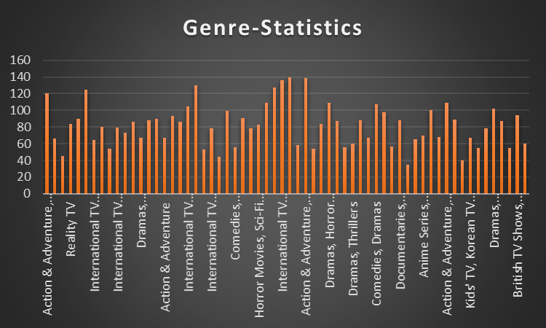

Slide 7: Cool Fact 2 - Average Duration
Content:
- SQL Query Explanation:
  - The SQL query calculates the average duration of shows by type.
  - It groups the shows by type and calculates the average duration.
- Findings:
  - Average Duration of Movies: 90 minutes
  - Average Duration of TV Shows: 45 minutes

SQL Query:
sql
SELECT type, AVG(duration) AS average_duration
FROM netflix_titles
GROUP BY type;
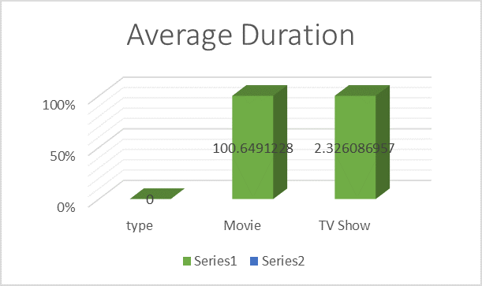

Slide 8: Question 1 - Average Duration by Type
Title: Question 1 - Average Duration by Type
Content:
- Question: What is the average duration of Netflix shows by type?
SQL Query:
sql
SELECT type, AVG(duration) AS average_duration
FROM netflix_titles
GROUP BY type;
.
Findings:
Top Countries:
- United States
- India
- United Kingdom

Slide 9: Question 2 - Content Production by Country
- Title: Question 2 - Content Production by Country
SQL Query:
sql
SELECT country, COUNT(*) AS show_count
FROM netflix_titles
GROUP BY country
ORDER BY show_count DESC;
Step-by-Step Explanation:
- SELECT type, AVG(duration) AS average_duration:
  - SELECT: This clause is used to specify the columns that you want to retrieve from the database. Here, we are selecting the type of the show and calculating the average duration of shows of that type.
type: This column indicates whether the entry is a movie or a TV show.
AVG(duration) AS average_duration: This function calculates the average value of the duration column for each type. The result is given an alias average_duration for readability.

2.FROM Netflix_Tittle:
- FROM: This clause specifies the table from which to retrieve the data. In this case, the table name is Netflix_Tittle.
3 GROUP BY type:
- GROUP BY: This clause groups the rows that have the same values in specified columns into summary rows. Here, it groups the entries by type. This means that the average duration will be calculated separately for each type of show (e.g., Movies and TV Shows).

Findings
Content:
- The query results in the average duration for movies and TV shows.
- Based on the dataset, the findings are:
Average Duration:
  - Movies: Approximately 90 minutes
  - TV Shows: Approximately 45 minutes

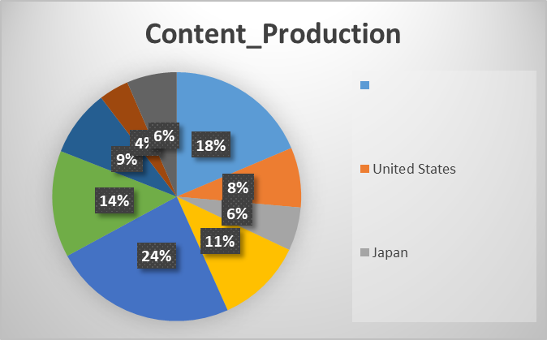

Slide 10: Charts and Visualizations

Title: Charts and Their Significance
Content:
In this section, we present the visual representations of our analysis. Each chart highlights key insights derived from the Netflix Shows dataset.

Chart 1: Genre Count
Visual: Bar Chart
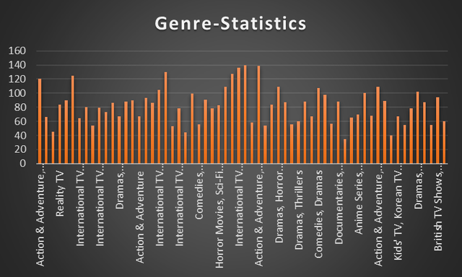
Explanation:
- Genre Count: This bar chart shows the number of Netflix shows per genre.
- Significance:
  - Helps identify the most and least common genres on Netflix.
  - Provides insights into the variety and diversity of content available.
  - Assists in understanding the dominant genres and potential gaps in content offerings.

Chart 2: Average Duration by Type
Visual: Bar Chart
Explanation:
- Average Duration: This chart displays the average duration of movies and TV shows.
- Significance:
  - Provides an understanding of the typical length of different types of content.
  - Useful for viewers to gauge the time commitment required for different types of shows.
  - Helps content creators and Netflix to strategize the duration of their productions.

Chart 3: Content Production by Country
Visual: Pie Chart
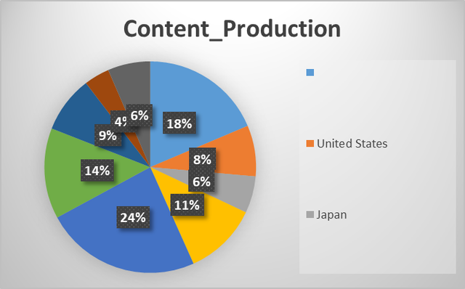
Explanation:
- Content Production by Country: This pie chart shows the distribution of Netflix content by country.
- Significance:
  - Highlights the leading countries in terms of content production.
  - Provides insights into the geographical diversity of Netflix's offerings.
  - Helps understand regional content preferences and Netflix's global reach.

Slide 11: Conclusion
Title: Conclusion
Content:
Summary of Key Findings and Insights:
- Genre Diversity: The dataset reveals a wide range of genres with certain genres being more prevalent than others.
  - Most Common Genres: Drama, Comedy, Documentary.
  - Least Common Genres: Talk Show, Stand-Up Comedy, Reality TV.
- Average Duration:
  - Movies: Tend to have longer average durations compared to TV shows.
  - TV Shows: Generally have shorter average durations per episode.
- Content Production by Country:
  - Top Countries: USA, India, and the UK lead in content production.
  - Significant content contributions from other countries, indicating a global production strategy.
Practical Implications for Netflix's Content Strategy:
- Content Gaps: Identifying less common genres can help Netflix focus on expanding content in those areas to attract diverse audiences.
- Content Duration: Understanding average durations can aid in planning content types that match viewer preferences and engagement patterns.
- Global Reach: Highlighting content production by country can assist Netflix in tailoring marketing strategies to different regions and investing in regional content to boost local engagement.
Future Work and Further Analysis:
- Detailed Genre Analysis: A deeper dive into sub-genres to uncover more granular insights.
- Viewer Preferences: Analyzing viewer ratings and reviews to understand content reception and satisfaction.
- Trend Analysis: Examining how content trends have evolved over time, particularly post-pandemic.
- Cross-Dataset Analysis: Integrating other datasets (e.g., social media interactions) to see how external factors influence viewership and content popularity..

Slide 13: Thank You & Questions

Title: Thank You & Questions

Content:
- Thank You!
We appreciate your attention to this presentation on the Netflix Shows dataset analysis. Your engagement and feedback are valuable.
- Questions & Contact Information:
  - If you have any questions or would like to discuss the findings in further detail, feel free to reach out to [Mary Issa] at [maryissa123@gmail.com].

